**(14 points)** The following is observed data for a closed loop traverse in a **Rural area**. Compute the **latitudes and departures** for all traverse courses. Compute the linear **error of closure** and the **relative** **precision**. Use the chart taken from the Kentucky Administrative Regulations to determine if the survey satisfies the unadjusted closure (minimum) specifications. Show your work in the space provided but enter your answers into the chart provided.

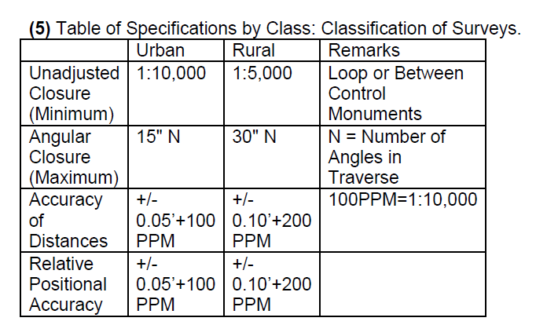

|  |  |  |  |  |
| --- | --- | --- | --- | --- |
| Station | Brg. ∢ | Length | Latitude | Departure |
| 1 |  |  |  |  |
|  | N 47°28’ E | 483.52’ |  |  |
| 2 |  |  |  |  |
|  | S 26°52’ E | 470.17’ |  |  |
| 3 |  |  |  |  |
|  | S 72°17’ W | 1241.62’ |  |  |
| 4 |  |  |  |  |
|  | N 52°30’ E | 773.40’ |  |  |
| 1 |  |  |  |  |
|  |  |  |  |  |

**(12 Points)**

Given the Northing and Easting coordinates of control points 900 and 901, determine the distance, bearing and azimuth from control point 900 to 901. (Round bearing and azimuth to full seconds)

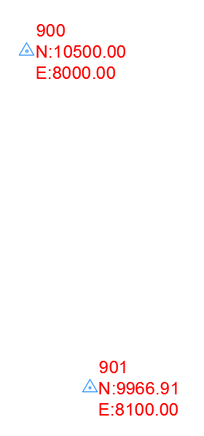

|  |  |
| --- | --- |
|  | CP900 to CP 901 |
| Distance |  |
| Azimuth |  |
| Bearing |  |

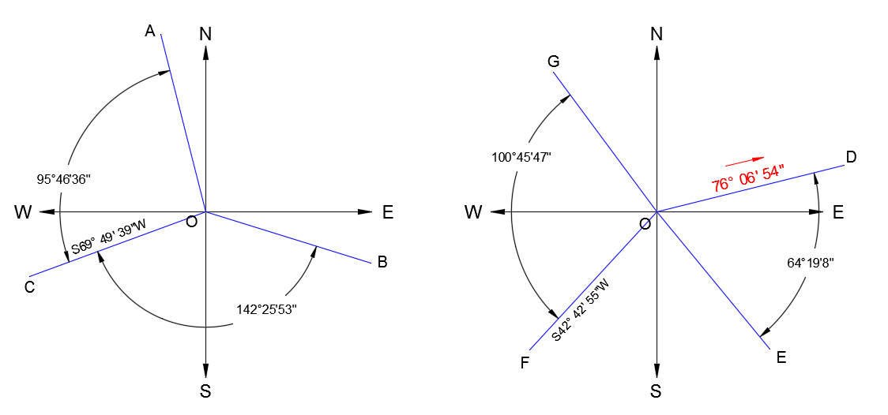

**(11 points)** Fill in the bearing, azimuth or both for each line segment in the diagram above.

|  |  |  |
| --- | --- | --- |
| Course | Bearing | Azimuth |
| OA |  |  |
| OB |  |  |
| OC | S 69°49’39”W |  |
| OD |  | 76°06’54” |
| OE |  |  |
| OF | S62°42’55”W |  |
| OG |  |  |

**(10 points)**

Given the interior angles of a four sided polygon and the Bearing of course AB, determine the bearing and azimuth of each course proceeding around the polygon in a clockwise direction.

**(show your work but enter answers in table)**

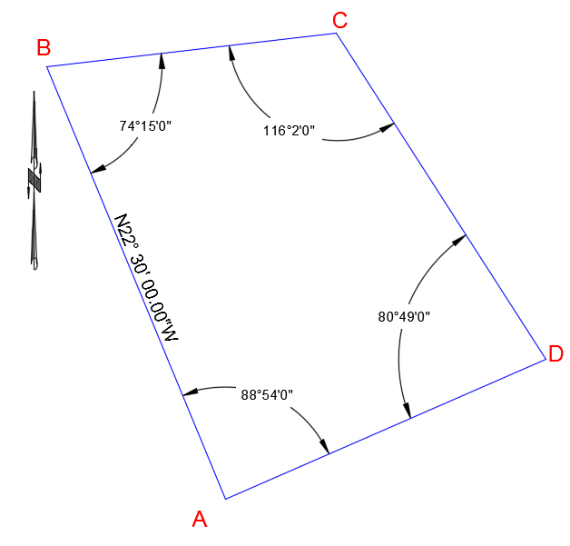

|  |  |  |
| --- | --- | --- |
| Course | Azimuth | Bearing |
| AB |  | N22°30’00”W |
| BC |  |  |
| CD |  |  |
| DA |  |  |